**Likes and Dislikes in English**

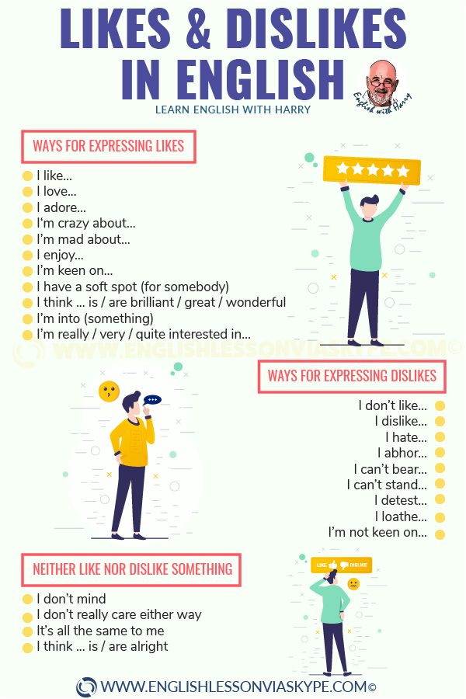

**Expressing Likes In English**

Here are some English phrases and words to say what you like:

* I adore
* I love
* I like
* I enjoy
* I’m into something
* I have a soft spot for something
* I’m quite keen on
* I think …. is/are brilliant …

**Expressing Likes In English**

Here are some English phrases and words to say what you like:

* I adore
* I love
* I like
* I enjoy
* I’m into something
* I have a soft spot for something
* I’m quite keen on
* I think …. is/are brilliant …
* For example:
* **I ADORE** having a massage after work. It helps me to relax.
* **I LOVE** shopping for clothes in the sales. I’ve got some great bargains.
* **I’M INTO** making music.
* **I LIKE** inviting my friends around for dinner. I ENJOY cooking a special meal for them.
* **I LIKE** ice-cream
* **I HAVE A SOFT SPOT** for Sarah
* I’m **QUITE KEEN ON** learning new languages
* **I THINK** Mark’s idea **IS BRILLIANT**
* **ADORE** here suggests a strong feeling of pleasure.

#### Expressing Dislikes In English

Here are some words in English to express things that you don’t like: I detest, I hate, I loathe, I’m not keen on, I can’t stand, I can’t bear …

For example:

**I’M NOT KEEN ON** watching soap operas.

**I DETEST** being stuck in a traffic jam.

**I HATE** Mondays!

**I LOATHE** visiting the dentist.

**I CAN’T STAND** Paula’s new boyfriend

Shopping **DRIVES ME CRAZY**

Both **I CAN’T STAND** and**I CAN’T BEAR** mean **I HATE**.

**DETEST** and **LOATHE** suggest strong feelings. These are things that you really don’t like doing, whereas **I’M NOT KEEN ON** expresses a preference.

We can use pronouns, nouns or verb **+ING** when we are expressing likes and dislikes in English:

I love it.  
I hate football.  
Waiting in queues drives me crazy.

## How To Talk About Likes And Dislikes In English?

Sarah, Kate, Steve and Tom are talking about what they like doing:

SARAH: I like inviting my friends round for dinner.  
KATE: I’m not keen on cooking. I enjoy going out for a meal.

KATE: I like going to watch football on Saturday.  
SARAH: I hate football. I’d rather go and play tennis.

STEVE: I like taking photographs on holiday.  
TOM: I’m not into photography. I’d rather buy postcards instead.

TOM: I’m going to the rugby match on Saturday. Would you like to come with me?  
STEVE: I hate rugby. I’ll be going shopping with Kate instead.

SARAH: I’m flying to Glasgow on Monday.  
KATE: I hate flying. I like going by train, even if it takes a little longer.

Now it’s your turn. What do you like doing in your spare time? What do you hate doing?